**Michał Suliborski**  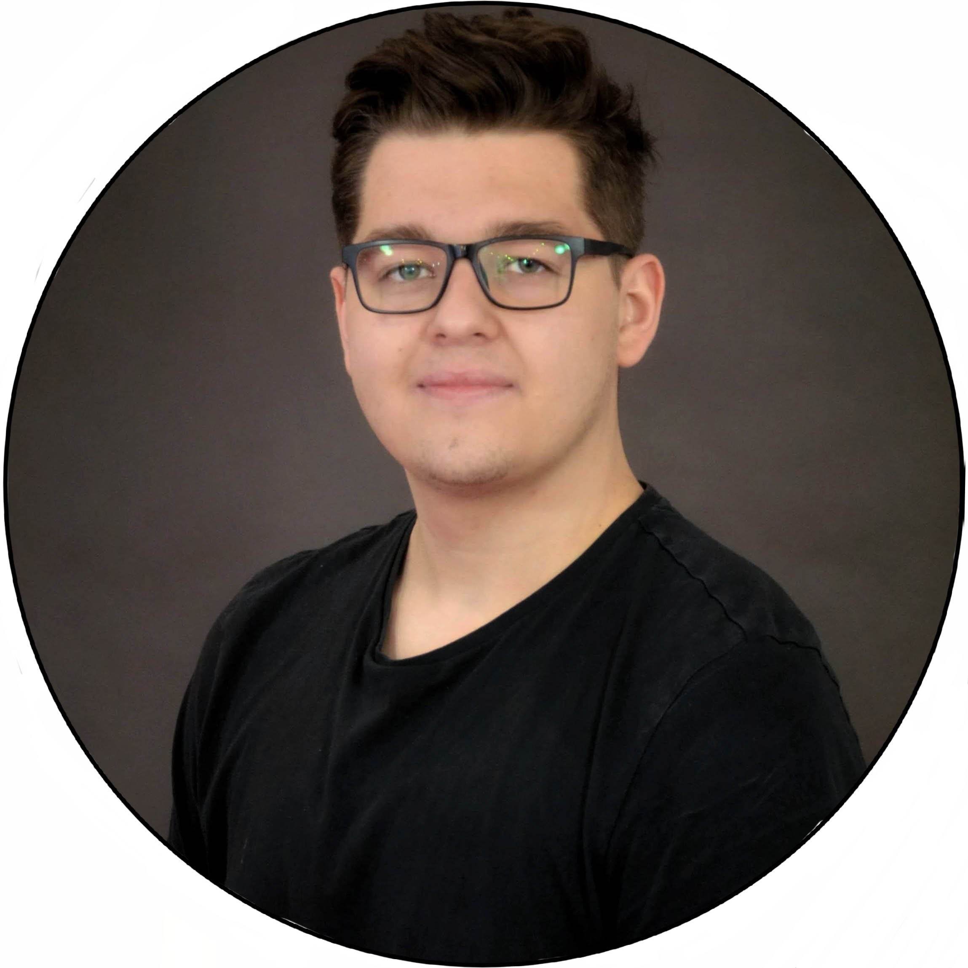

*Team Leader*

Ambitious and passionate application and game developer. Constantly looking for opportunities to expand his knowledge, improve already developed skills and acquire new ones. Interested in TV shows, films and books. His knowledge was always a valuable asset for a team.

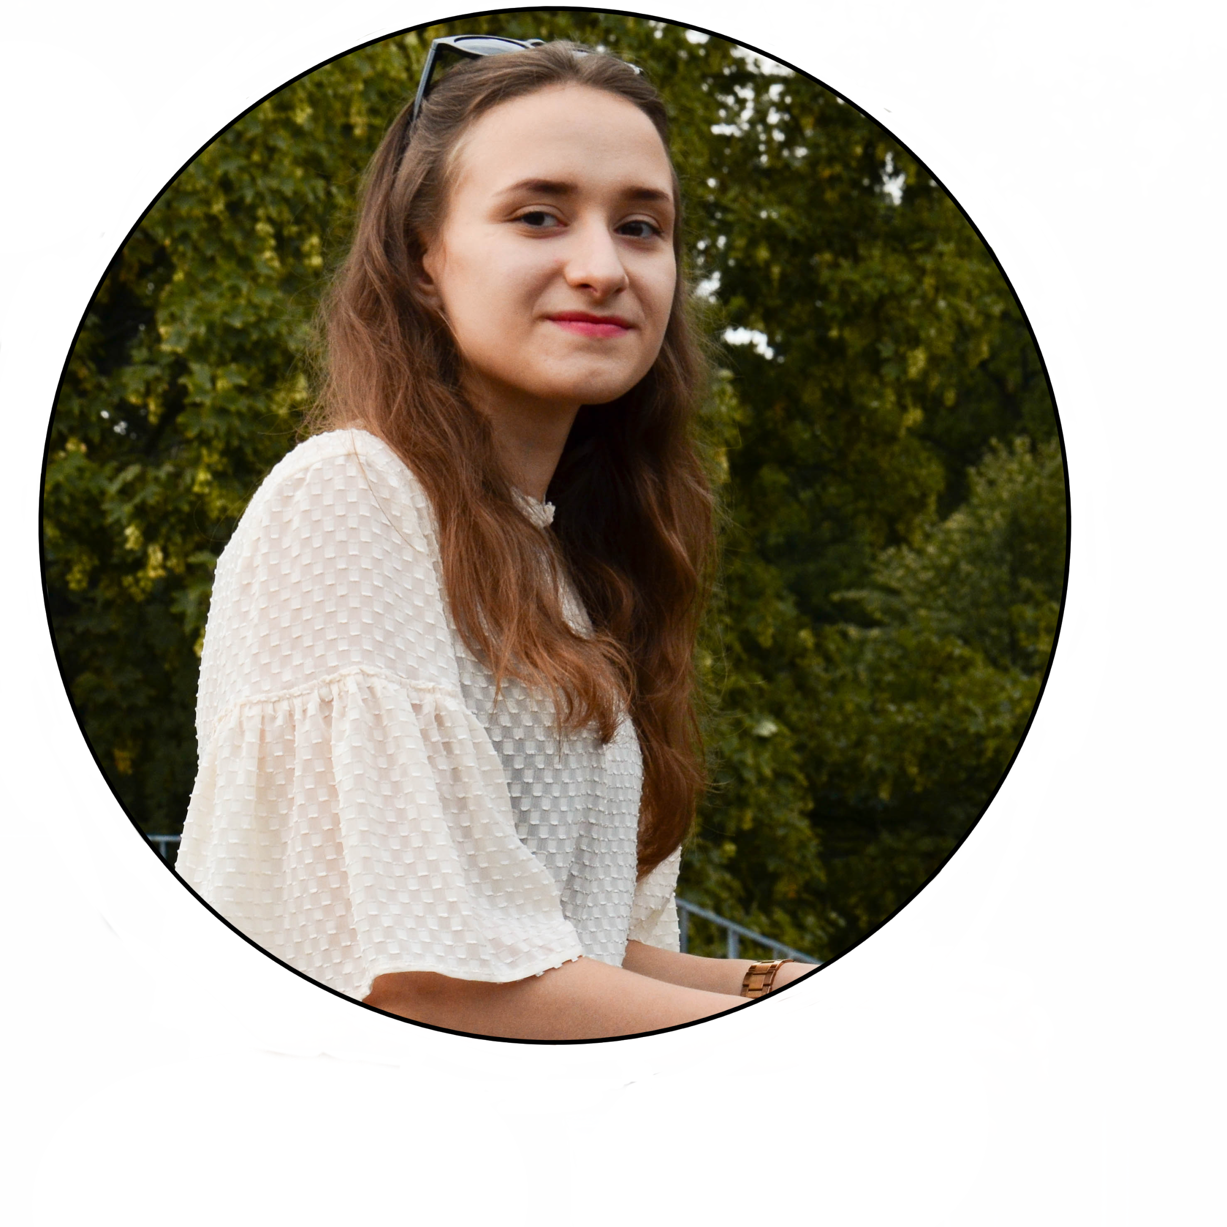

**Anna Preczyńska**

*Designer*

Person responsible for creating the prototypes of the application. Cooperative, determined and cheerful person interested in photography, climbing and riding motorbike. Her distinctive feature is the almost constant smile on her face.

**Yurii Shcheoholiev**  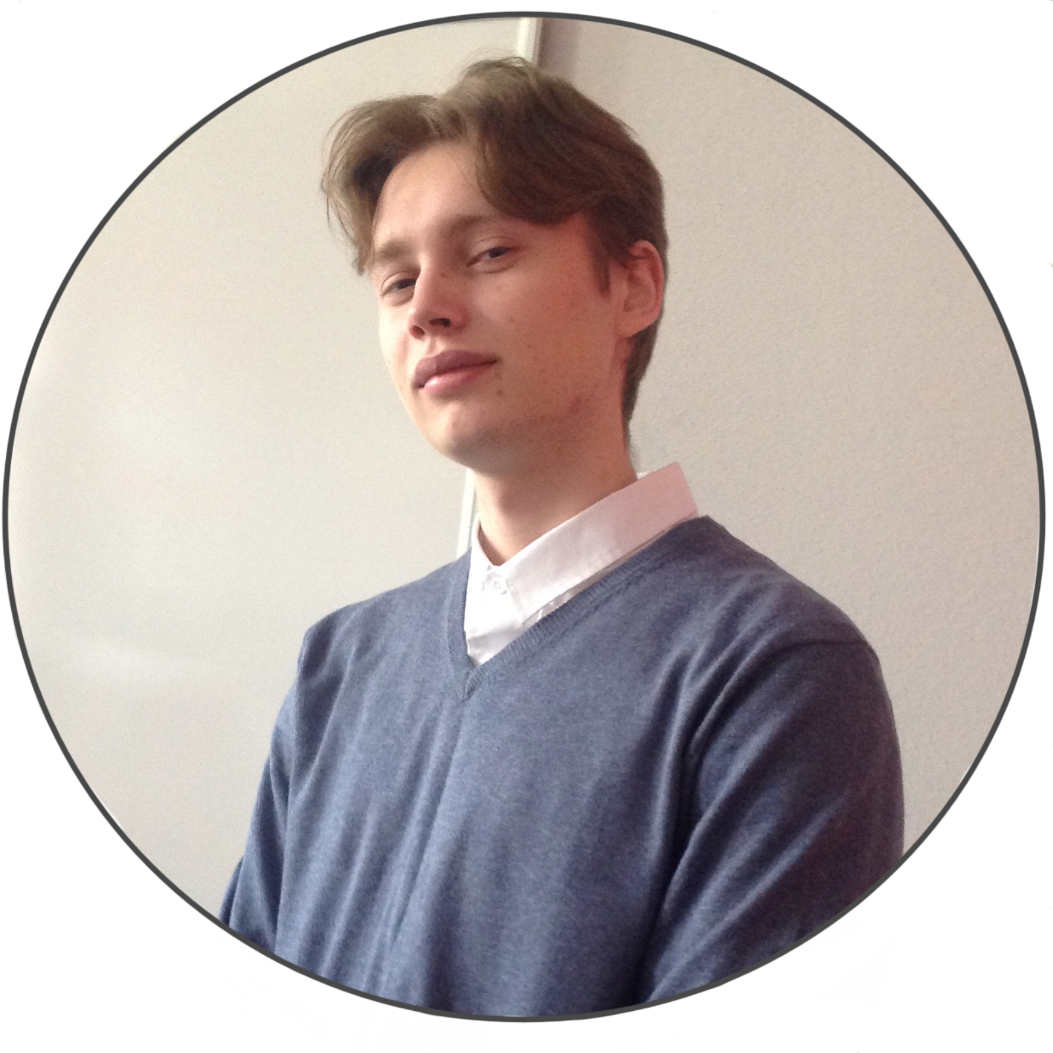

*Tester*

Easygoing and reliable member of a team. Was responsible for the meetings calling, teamwork and testing the application. By not being a babbler type he is always ready to listen and support.

**Mariusz Pisarski**  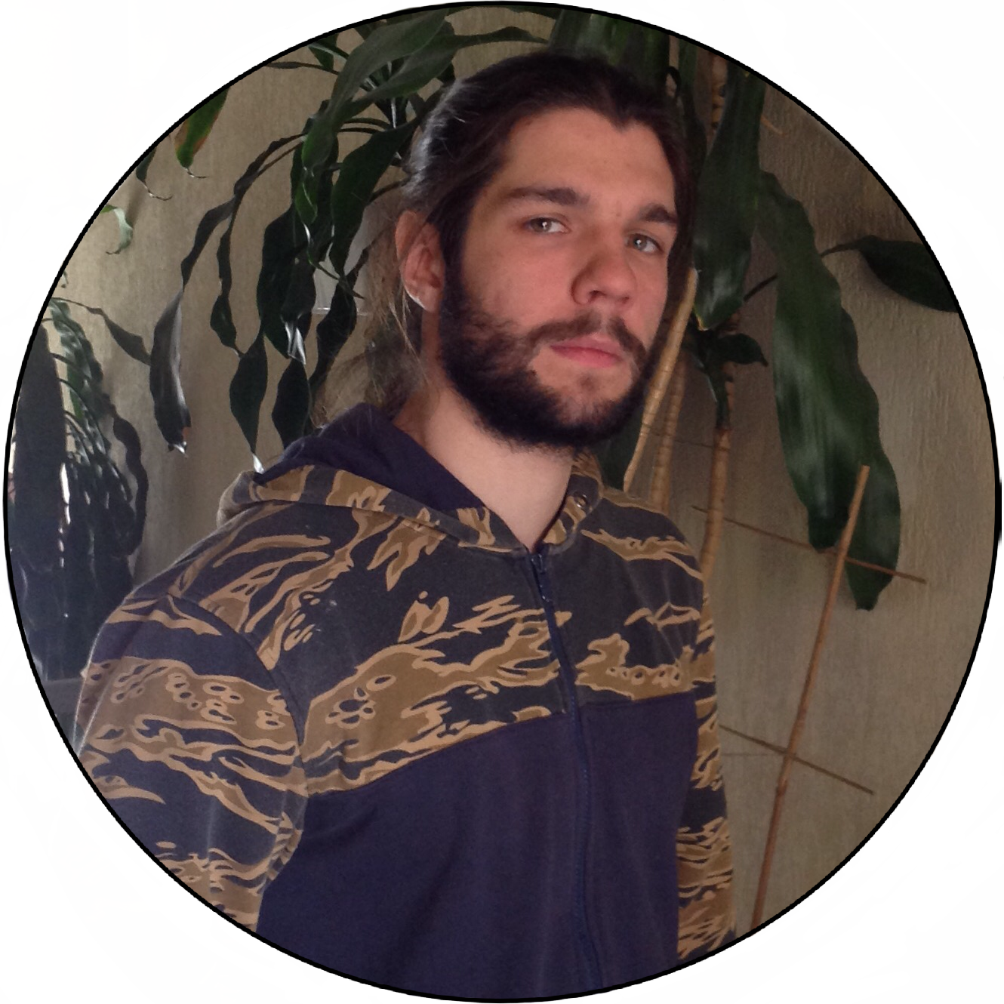

*Contact Person*

Diplomatic and confident person, who apart from coding duties was responsible for contact with the main stakeholders. His connections also allowed early testing of the application prototypes. Energetic and enthusiastic. Constantly suffering from chronic lack of adrenaline rush. Despite being a programmer, he is interested in extreme sports and music as well.